VISVESVARAYA TECHNOLOGICAL UNIVERSITY,
BELGAUM, KARNATAKA

MINOR-PROJECT-II

REPORT ON,

“CROP YIELD PREDICTION”

Submitted in partial fulfillment of the requirement for the award of the degree of

BACHELOR OF ENGINEERING
IN
COMPUTER SCIENCE AND ENGINEERING

Submitted by

USN | NAME
2SD20CS016 Anirudh Gudisagar
2SD20CS031 Bharatesh Nagaraj Labhagond
2SD20CS033 Bhoomika Wali
2SD20CS113 Sushmita Patil

Under the Guidance of
Prof. Yashodha Sambrani
Dept. of CSE, SDMCET, Dharwad



DEPARTMENT OF COMPUTER SCIENCE AND ENGINEERING
S.D.M. COLLEGE OF ENGINEERING & TECHNOLOGY,
DHARWAD-580002
2023
S.D.M COLLEGE OF ENGINEERING & TECHNOLOGY,
DHARWAD –580002


DEPARTMENT OF COMPUTER SCIENCE AND ENGINEERING

CERTIFICATE

Certified that the Minor-Project-2 work and presentation entitled “CROP YIELD PREDICTION” is a bonafide work carried out by by Anirudh Gudisagar (2SD20CS016), Bharatesh Nagaraj Labhagond (2SD20CS031), Bhoomika Wali (2SD20CS033), and Sushmita Patil (2SD20CS113), students of S. D. M. College of Engineering & Technology, Dharwad, in partial fulfillment for the award of Bachelor of Engineering in Computer Science and Engineering of Visvesvaraya Technological University, Belgaum, during the year 2022-2023. It is certified that all corrections/suggestions indicated for internal assessment have been incorporated in the report deposited in the department library. The Minor-Project-1 has been approved, as it satisfies the academic requirements in respect of project report prescribed for the said degree.

----------------------- ------------------------
Prof.Yashodha Sambrani Dr. S M Joshi
Project Guide HOD-CSE

Name of Examiners Signature with date
1.
2.

ABSTRACT

Yield of each crop depends on its dependent factors. It is very important to predict the yield of a crop to help farmers. Crop Yield Prediction is predicting the yield of a crop in future based on the dependent factors. Crop yield is dependent on factors like district, season, year ,crop, area or the geographical location. Prediction is done using machine learning algorithm like Random Forest Regression using historical data of dependent factors.
In Crop Yield Prediction, we have chosen Karnataka regions for the prediction of crop yield. Using the district, season, year, crop, area and production data from 1997-2014 of Karnataka regions’ crop yield is predicted. To predict the yield one of the machine learning algorithm is used i.e. Random Forest Regression. The result of predicted value is shown in tonnes per hectare.
Crop Yield Prediction helps farmers to grow a crop which gives more yields based on the algorithmic prediction. Thus it helps to reduce loss for the farmers. Prediction also helps to increase the crop yield.

Table of Contents

PROBLEM STATEMENT 2
CHAPTER 1: INTRODUCTION 3
CHAPTER 2: LITERATURE SURVEY 4
CHAPTER 3: DETAILED DESIGN 5
CHAPTER 4: PROJECT SPECIFIC REQUIREMENTS 6
CHAPTER 5: IMPLEMENTATION 7
CHAPTER 6: RESULTS 8
CHAPTER 7: CONCLUSION AND FUTURE SCOPE 9
REFERENCES 10

PROBLEM STATEMENT

Yield of any crop depends on external factors such as district , season, area etc. It is very important to predict the yield of crops as it allows for better planning, resource allocation, and decision-making. Crop Yield Prediction involves predictive model to predict the yield of crops based on dependent factors.

CHAPTER 1: INTRODUCTION

Agriculture is one of the main sectors to be impacted by different sources like seasonal changes, area of cultivation etc., Crop yield prediction is based on various kinds of data collected and extracted by using data mining techniques such as machine learning techniques.
Predicting the crop yield can be extremely useful for farmers. If they have an idea of the amount of yield they can expect, they can contract their crop prior to harvest, often securing a more competitive price than if they were to wait until after harvest. The involvement of experts in prediction of crop yield leads to issues like lack of knowledge about natural events, negation of personal perception and fatigue etc. such issues can be to overcome by using the models and decision tools for crop yield prediction.
Achieving maximum crop yield at minimum cost is one of the goals of agricultural production. Early detection and management of problems associated with crop yield indicators can help increases yield and subsequent profit. Predictions could be used by crop managers to minimize losses when unfavorable conditions may occur. Additionally, these predictions could be used to maximize crop prediction when potential exists for favorable growing conditions.
The crop yield prediction comprises of mostly all essential parameters that are needed for the better yield of crop. This enhances the classification results of the crop yield. In general, one of the difficulties faced in the prediction process is that most of the essential parameters that are necessary to consider for the accurate prediction are not consider. It reduces the efficiency of the predicted results which in turn leads to lack of proper forecasting of the crop yield. It is also more complex to predict the optimized number of input parameters that are to be considered in the prediction process.

CHAPTER 2: LITERATURE SURVEY

- Title: CRY—an improved crop yield prediction model using bee hive clustering
approach for agricultural data sets

Authors: Ananthara, M. G., Arunkumar, T., & Hemavathy, R.

Observations: Agricultural researchers over the world insist on the need for an efficient mechanism to predict and improve the crop growth. The need for an integrated crop growth control with accurate predictive yield management methodology is highly felt among farming community. The complexity of predicting the crop yield is highly due to multi dimensional variable metrics and unavailability of predictive modeling approach, which leads to loss in crop yield. This research paper suggests a crop yield prediction model (CRY) which works on an adaptive cluster approach over dynamically updated historical crop data set to predict the crop yield and improve the decision making in precision agriculture. CRY uses bee hive modeling approach to analyze and classify the crop based on crop growth pattern, yield. CRY classified dataset had been tested using Clementine over existing crop domain knowledge. The results and performance shows comparison of CRY over with other cluster approaches.

2) Title: An intelligent system based on kernel methods for crop yield prediction

Authors: Awan, A. M., & Sap, M. N. M.

Observations: This paper presents work on developing a software system for predicting crop yield from climate and plantation data. At the core of this system is a method for unsupervised partitioning of data for finding spatio-temporal patterns in climate data using kernel methods which offer strength to deal with complex data. For this purpose, a robust weighted kernel k-means algorithm incorporating spatial constraints is presented. The algorithm can effectively handle noise, outliers and auto-correlation in the spatial data, for effective and efficient data analysis, and thus can be used for predicting oil-palm yield by analyzing various factors affecting the yield.

3) Title: Fuzzy Logic based Crop Yield Prediction using Temperature and Rainfall
parameters predicted through ARMA, SARIMA, and ARMAX models

Authors: Bang, S., Bishnoi, R., Chauhan, A. S., Dixit, A. K., & Chawla, I.

Observations: Agriculture plays a significant role in the economy of India. This makes crop yield prediction an important task to help boost India's growth. Crops are sensitive to various weather phenomena such as temperature and rainfall. Therefore, it becomes crucial to include these features when predicting the yield of a crop. Weather forecasting is a complicated process. In this work, three methods are used to forecast- ARMA (Auto Regressive Moving Average), SARIMA (Seasonal Auto Regressive Integrated Moving Average) and ARMAX (ARMA with exogenous variables). The performance of the three is compared and the best model is used to predict rainfall and temperature which are in turn used to predict the crop yield based on a fuzzy logic model.

4) Title: Crop Yield Prediction Using Data Analytics and Hybrid Approach

Authors: Bhosale, S. V., Thombare, R. A., Dhemey, P. G., & Chaudhari, A. N.

Observations: Agricultural data is being produced constantly and enourmosly. As a result, agricultural data has come in the era of big data. Smart technologies contribute in data collection using electronic devices. In our project we are going to analyse and mine this agricultural data to get useful results using technologies like data analytics and machine learning and this result will be given to farmers for better crop yield in terms of efficiency and productivity.

5) Title: A study on various data mining techniques for crop yield prediction

Author: Gandge, Y

Observations: India is a country where agriculture and agriculture related industries are the major source of living for the people. Agriculture is a major source of economy of the country. It is also one of the country which suffer from major natural calamities like drought or flood which damages the crop. This leads to huge financial loss for the farmers thus leading to the suicide. Predicting the crop yield well in advance prior to its harvest can help the farmers and Government organizations to make appropriate planning like storing, selling, fixing minimum support price, importing/exporting etc. Predicting a crop well in advance requires a systematic study of huge data coming from various variables like soil quality, pH, EC, N, P, K etc. As Prediction of crop deals with large set of database thus making this prediction system a perfect candidate for application of data mining. Through data mining we extract the knowledge from the huge size of data. This paper presents the study about the various data mining techniques used for predicting the crop yield. The success of any crop yield prediction system heavily relies on how accurately the features have been extracted and how appropriately classifiers have been employed. This paper summarizes the results obtained by various algorithms which are being used by various authors for crop yield prediction, with their accuracy and recommendation.

CHAPTER 3: DETAILED DESIGN
System Architecture:
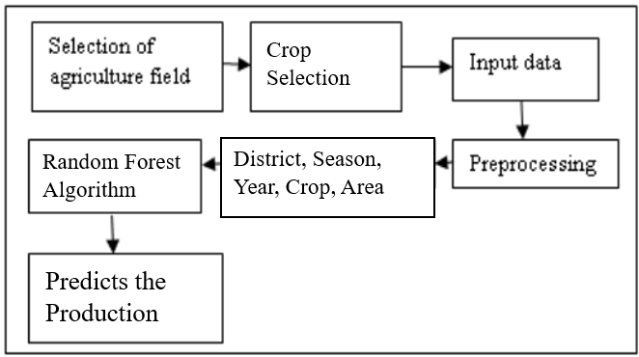
Fig. (1)

A Brief overview of the Crop Yield Prediction System:
1. Input data: Data may include information regarding District, Season, year, Area,
crop name.
2. Preprocessing: Data which is collected should be preprocessed redundant data,
inconsistent should be taken care.
3. Attribute Selection: Important Features have to be extracted like District,
Season, year, Area, crop name.
4. Classification Algorithm: An appropriate and efficient algorithm should be
employed using Random Forest algorithm.
5. Result: prediction or recommendation can be provided to the farmers based on
the results obtained in tonnes per hectare value.
USE CASE DIAGRAM:
Use case diagram in the Unified Modeling Language (UML) is a type of behavioral diagram defined by and created from a Use-case analysis. Its purpose is to present a graphical overview of the functionality provided by a system in terms of actors, their goals (represented as use cases), and any dependencies between those use cases. The main purpose of a use case diagram is to show what system functions are performed for which actor. Roles of the actors in the system can be depicted.

User
Input data
Preprocessing
Training
Regression
Fig. (2)
CLASS DIAGRAM:
In software engineering, a class diagram in the Unified Modeling Language (UML) is a type of static structure diagram that describes the structure of a system by showing the system's classes, their attributes, operations (or methods), and the relationships among the classes. It explains which class contains information.
Input

Input data

Preprocessing ( )
Output

Regression

Finally get Regression&Display Result: Predicted amount of Production

ACTIVITY DIAGRAM:
Activity diagrams are graphical representations of workflows of stepwise activities and actions with support for choice, iteration and concurrency. In the Unified Modeling Language, activity diagrams can be used to describe the business and operational step-by-step workflows of components in a system. An activity diagram shows the overall flow of control.

Input dataset
Preprocessing
Training
Prediction using proposed algorithm (Random Forest algorithm)
Predicted amount of Production
Fig. (3)

CHAPTER 4: PROJECT SPECIFIC REQUIREMENTS

Hardware Requirements:
● Processors : Windows 7 and above
● Processor Speed : 2.50 GHZ and above
● RAM : 8 GB
● Storage : 20 GB

Software Requirements:
● Operating system : Windows 7 and above
● Coding Language : Python
● Tools : Jupyter Notebook

Software Tools:
Python: Python is a general purpose, dynamic, high-level, and interpreted programming language. It supports Object Oriented programming approach to develop applications. It is simple and easy to learn and provides lots of high-level data structures. Python is easy to learn yet powerful and versatile scripting language, which makes it attractive for Application Development. Python's syntax and dynamic typing with its interpreted nature make it an ideal language for scripting and rapid application development.
Jupyter Notebook: The Jupyter Notebook is an open-source web application that allows you to create and share documents that contain live code, equations, visualizations, and narrative text. Its uses include data cleaning and transformation, numerical simulation, statistical modeling, data visualization, machine learning, and much more.
Jupyter Notebook (formerly IPython Notebooks) is a web-based interactive computational environment for creating Jupyter notebook documents. The “notebook” term can colloquially make reference to many different entities, mainly the Jupyter web application, Jupyter Python web server, or Jupyter document format depending on context. According to the official website of Jupyter, Project Jupyter exists to develop open-source software, open-standards, and services for interactive computing across dozens of programming languages.

CHAPTER 5: IMPLEMENTATION

MODULES:
- Dataset
- Preprocessing
- Model Selection
- Analyze and Prediction
- Accuracy on test set

MODULES DESCSRIPTION:

- Dataset:
This is the first real step towards the real development of a machine learning model, collecting data. This is a critical step that will cascade in how good the model will be, the more and better data that we get, the better our model will perform.
There are several techniques to collect the data, like web scraping, manual interventions and etc.

The dataset consists of 21078 individual data. There are 6 columns in the dataset,
which are described below.
Id: unique id
District_Name: District in Karnataka
Crop_Year: which year crop harvested.

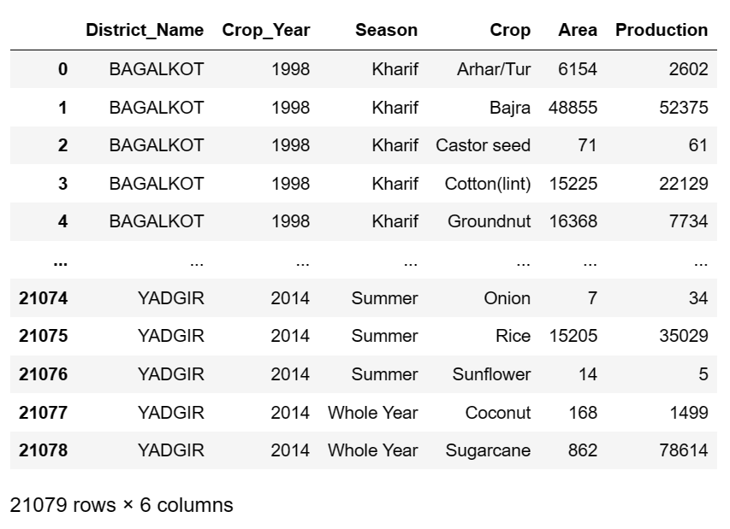
Fig. (4)

Season:
*Winter, occurring from December to February. ...
*Summer or pre-monsoon season, lasting from March to May. ...
*Monsoon or rainy or kharif season, lasting from June to September. ...
* Post-monsoon or autumn or rabi season, lasting from October to November.
Crop: crop name
Area: how much area? they harvested.
Production: production amount

- Preprocessing:
we will transform the data. By getting rid of missing data and removing some columns. First we will create a list of column names that we want to keep or retain. Next we drop or remove all columns except for the columns that we want to retain. Finally we drop or remove the rows that have missing values from the data set.

- Model Selection:
Random Forest regression:
Random Forest Regression is a supervised learning algorithm that uses ensemble learning method for regression. Ensemble learning method is a technique that combines predictions from multiple machine learning algorithms to make a more accurate prediction than a single model.
The Fig. 1 below shows the structure of a Random Forest. You can notice that the trees run in parallel with no interaction amongst them. A Random Forest operates by constructing several decision trees during training time and outputting the mean of the classes as the prediction of all the trees. To get a better understanding of the Random Forest algorithm, let’s walk through the steps:
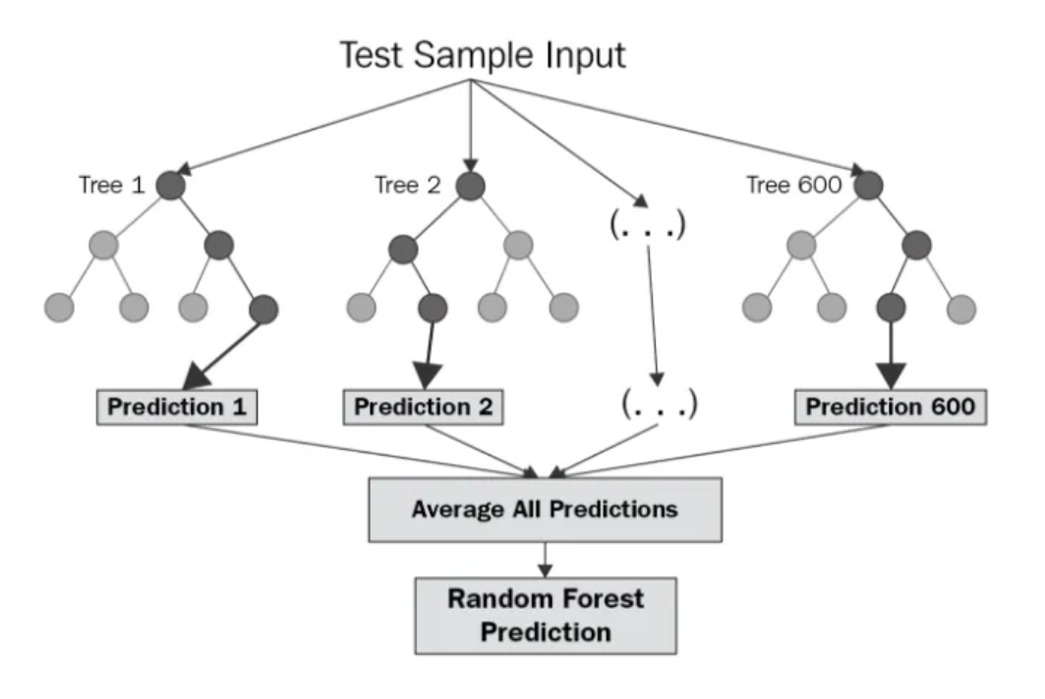
Fig. (5)

Parameters for selection of Random Forest
Below are some points that explain why we should use the Random Forest algorithm:
- It takes less training time as compared to other algorithms.
- It predicts output with high accuracy, even for the large dataset it runs efficiently.
- It can also maintain accuracy when a large proportion of data is missing.

Working of Random Forest algorithm
Random Forest works in two-phase first is to create the random forest by combining N decision tree, and second is to make predictions for each tree created in the first phase.
The Working process can be explained in the below steps and diagram:
Step-1: Select random K data points from the training set.
Step-2: Build the decision trees associated with the selected data points (Subsets).
Step-3: Choose the number N for decision trees that you want to build.
Step-4: Repeat Step 1 & 2.
Step-5: For new data points, find the predictions of each decision tree, and assign the new data points to the category that wins the majority votes.

Example: Suppose there is a dataset that contains multiple fruit images. So, this dataset is given to the Random forest classifier. The dataset is divided into subsets and given to each decision tree. During the training phase, each decision tree produces a prediction result, and when a new data point occurs, then based on the majority of results, the Random Forest classifier predicts the final decision. Consider the below image:

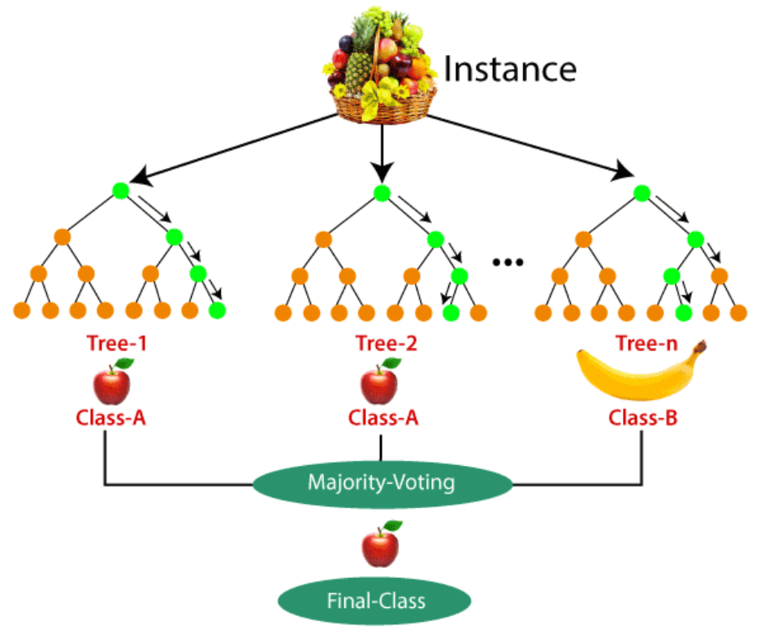
Fig. (6)

- Analyze and Prediction:

In the actual dataset, we chose only 5 features :
District_Name: District in india
Crop_Year: which year crop harvested.
Season:
*Winter, occurring from December to February. ...
*Summer or pre-monsoon season, lasting from March to May. ...
*Monsoon or rainy season, lasting from June to September. ...
* Post-monsoon or autumn season, lasting from October to November.
Crop: crop name
Area: how much area? they harvested.

- Accuracy on test set:
We got an accuracy around 80% on test set.

Analysis and Implementation Code:
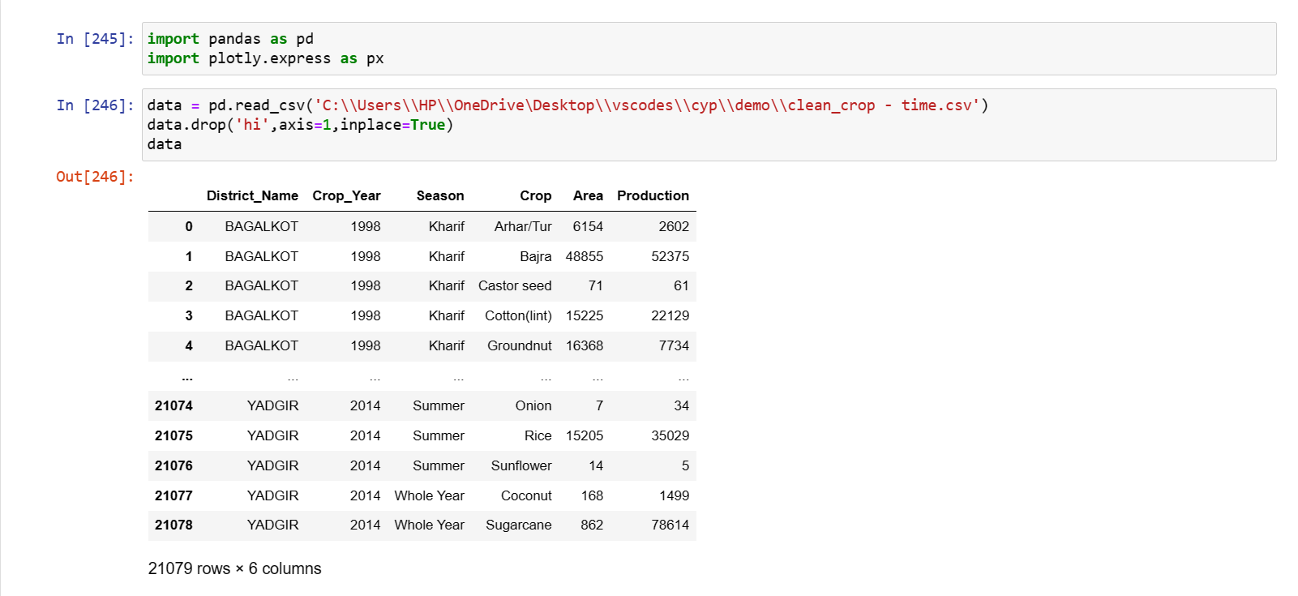
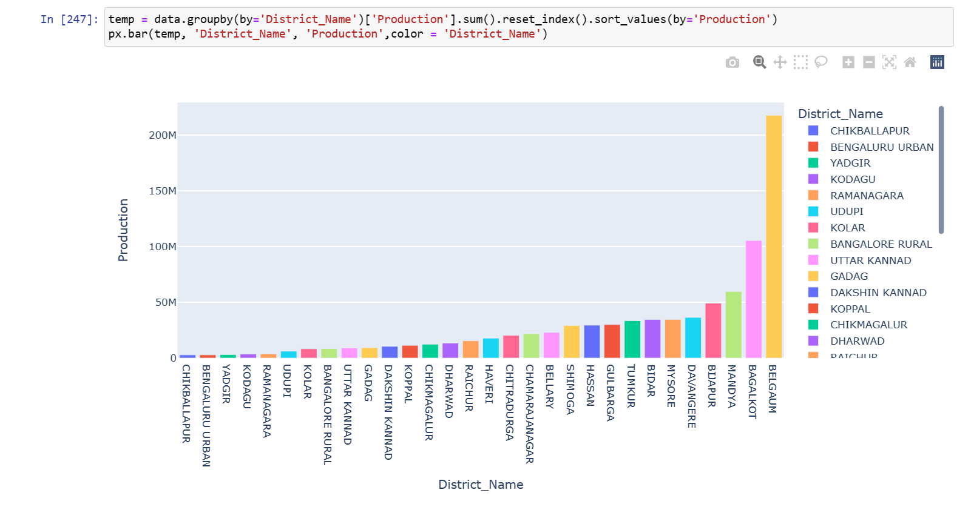
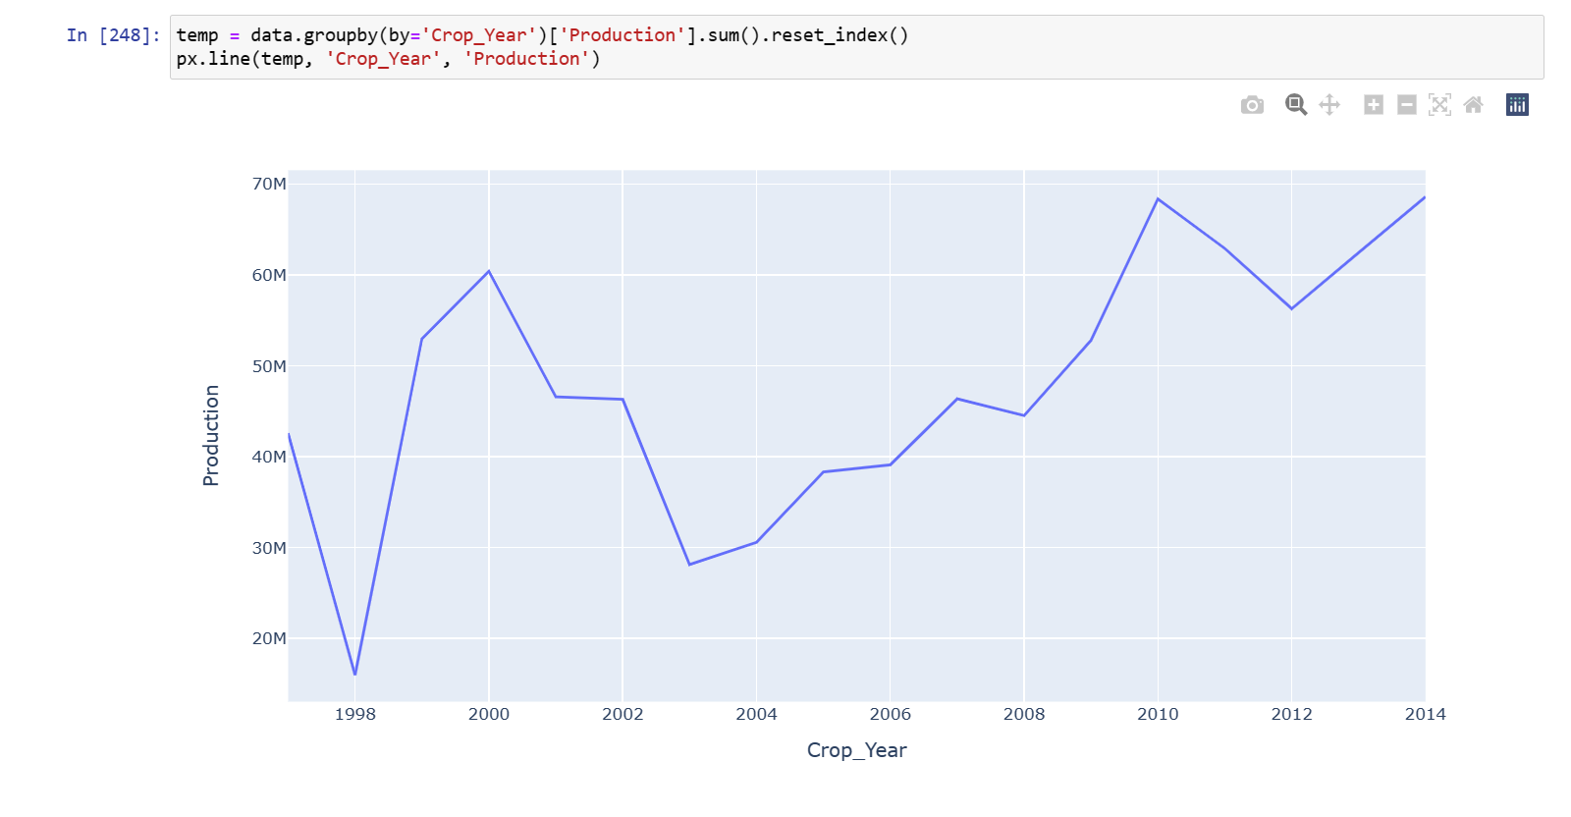
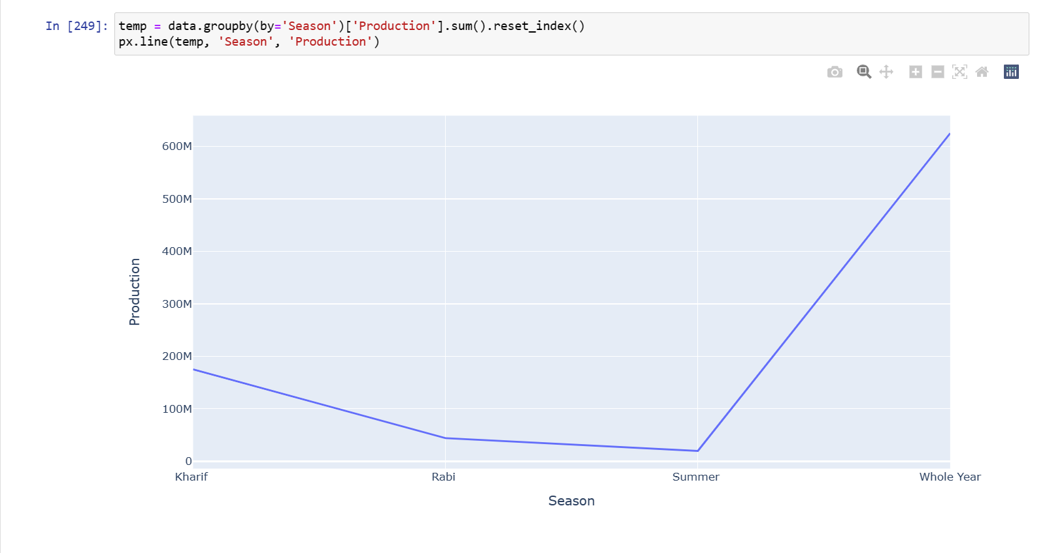
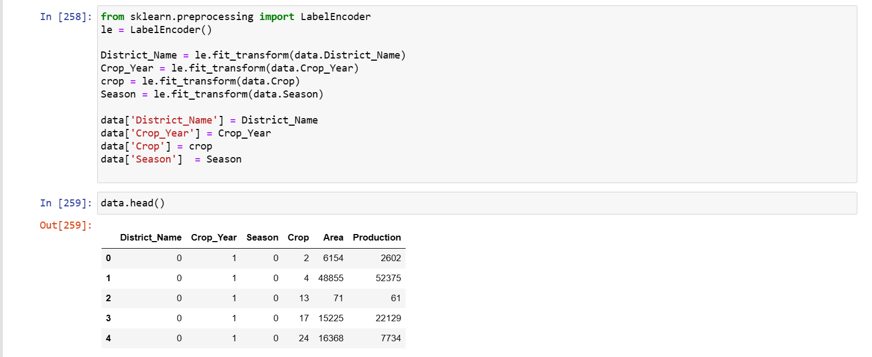
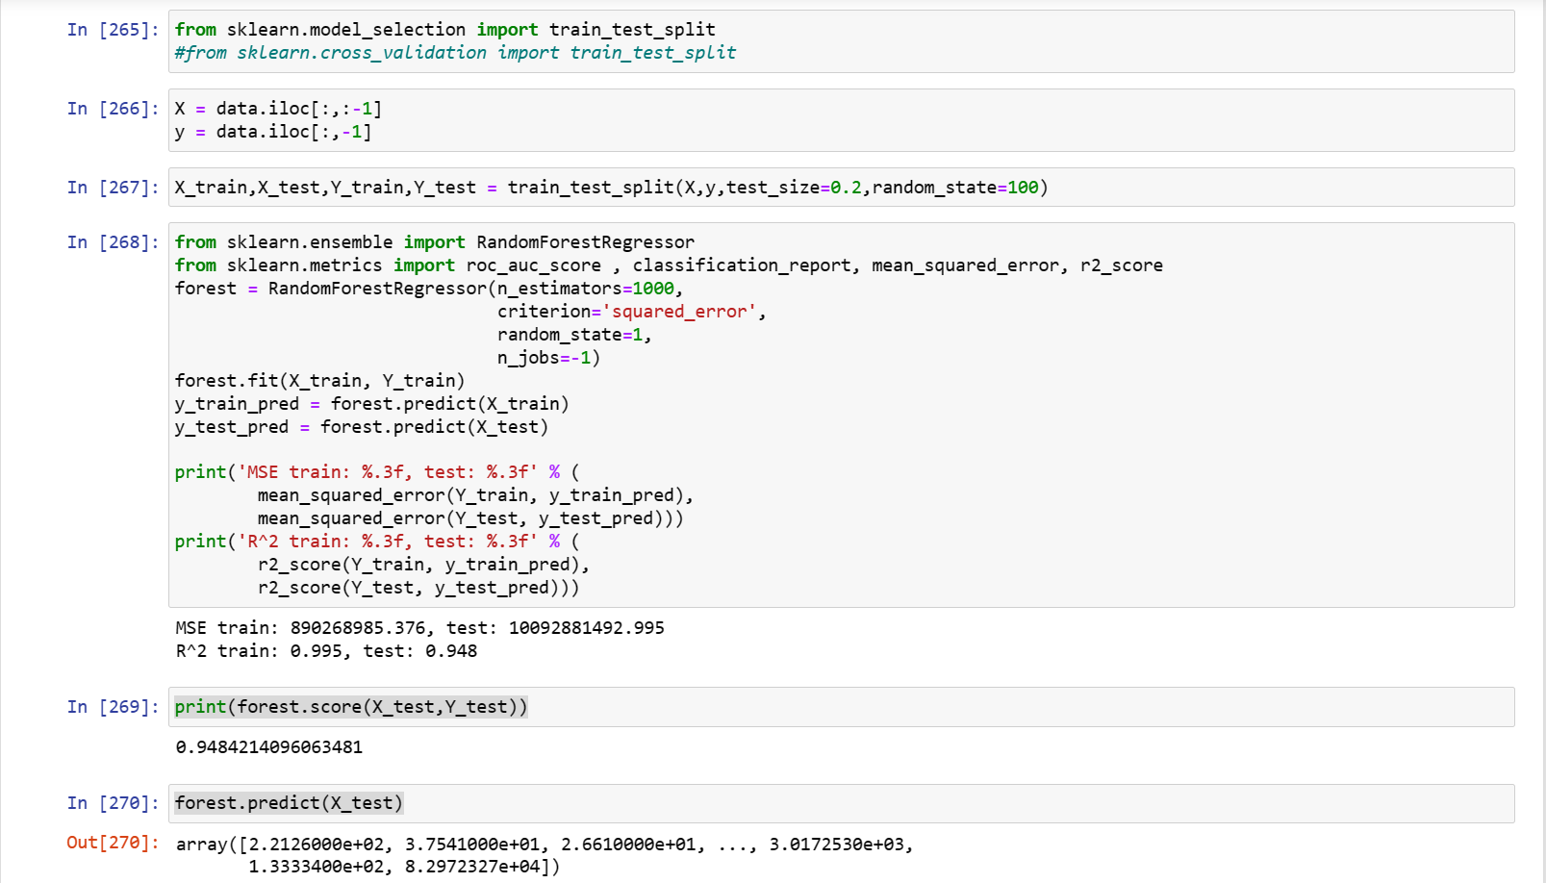
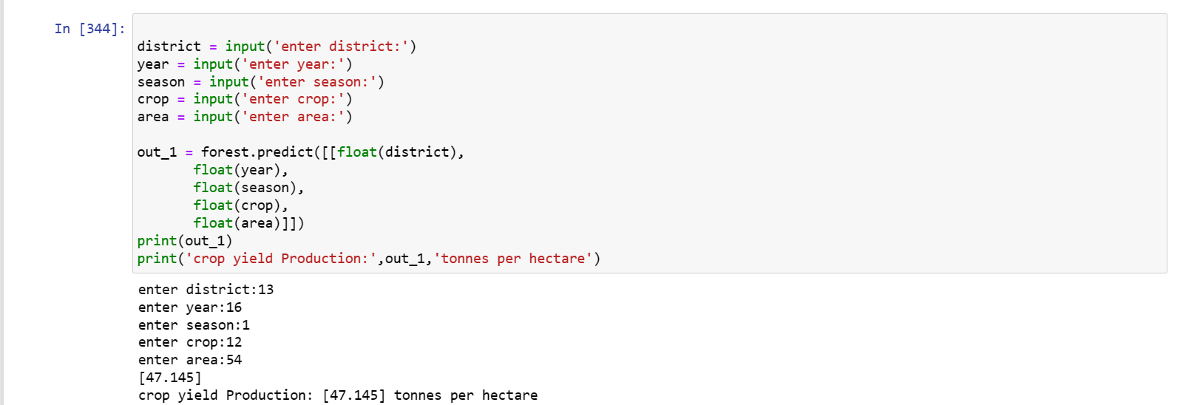
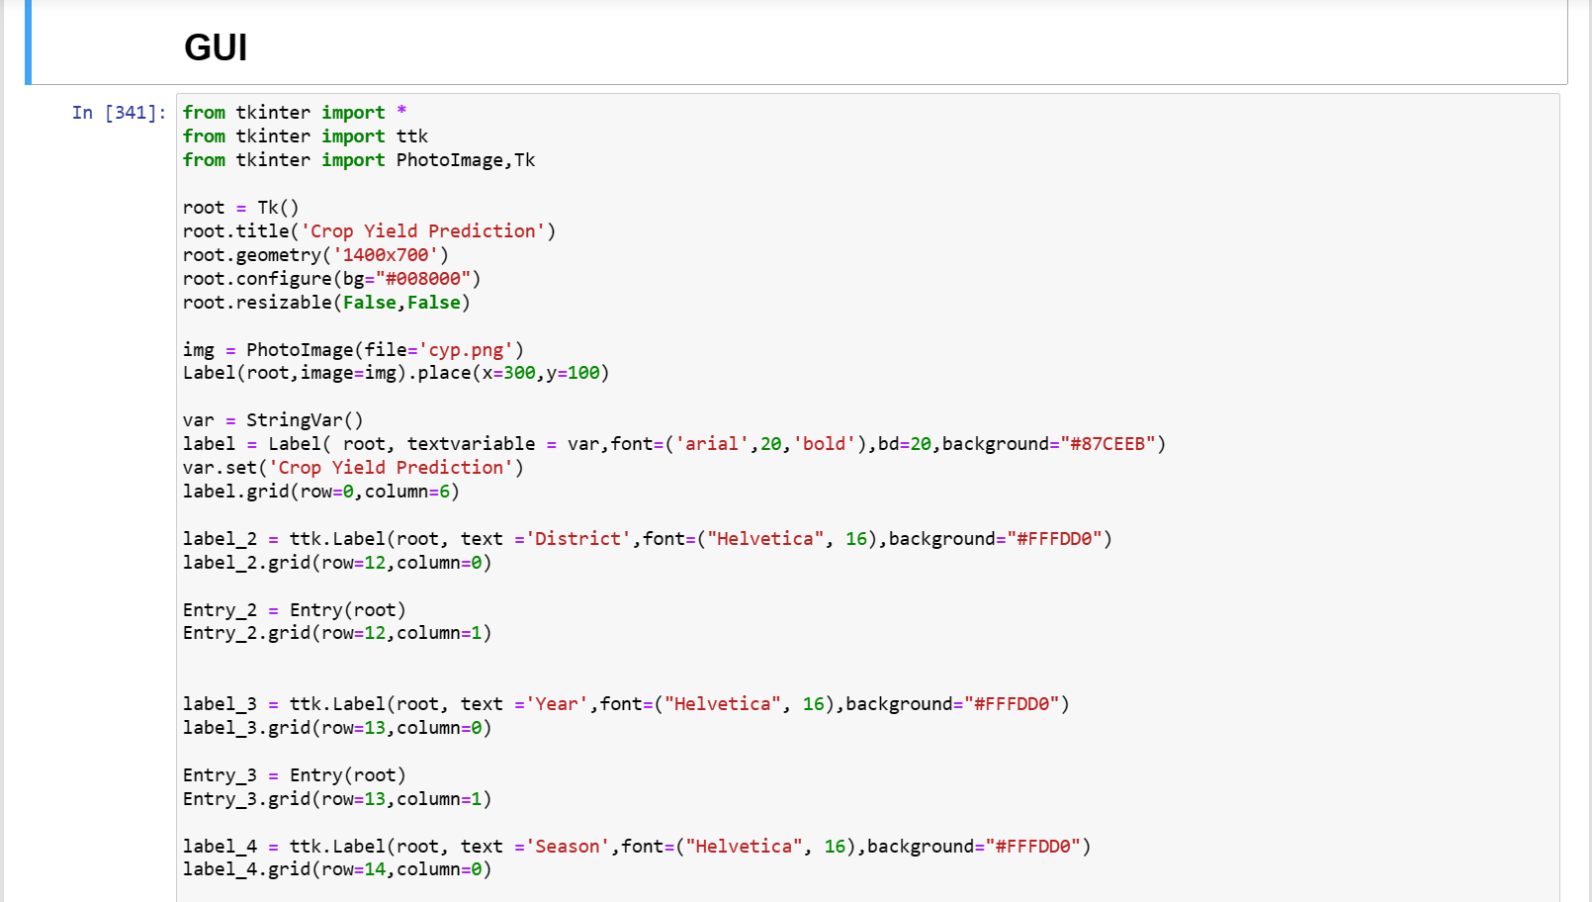
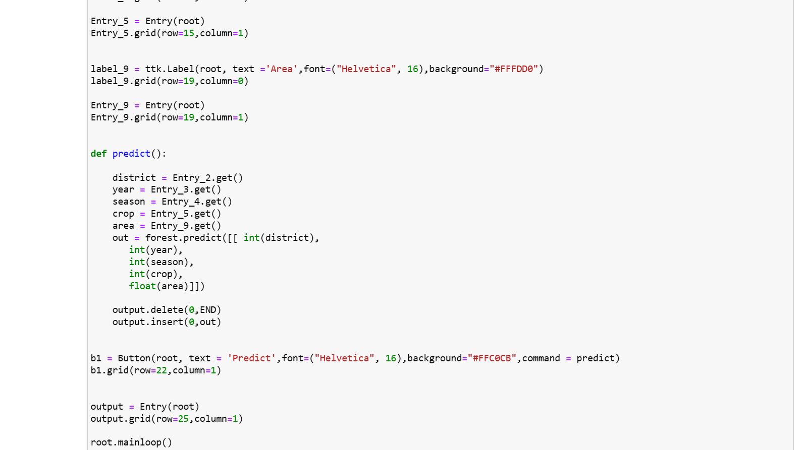

CHAPTER 6: RESULTS

Dashboard page:
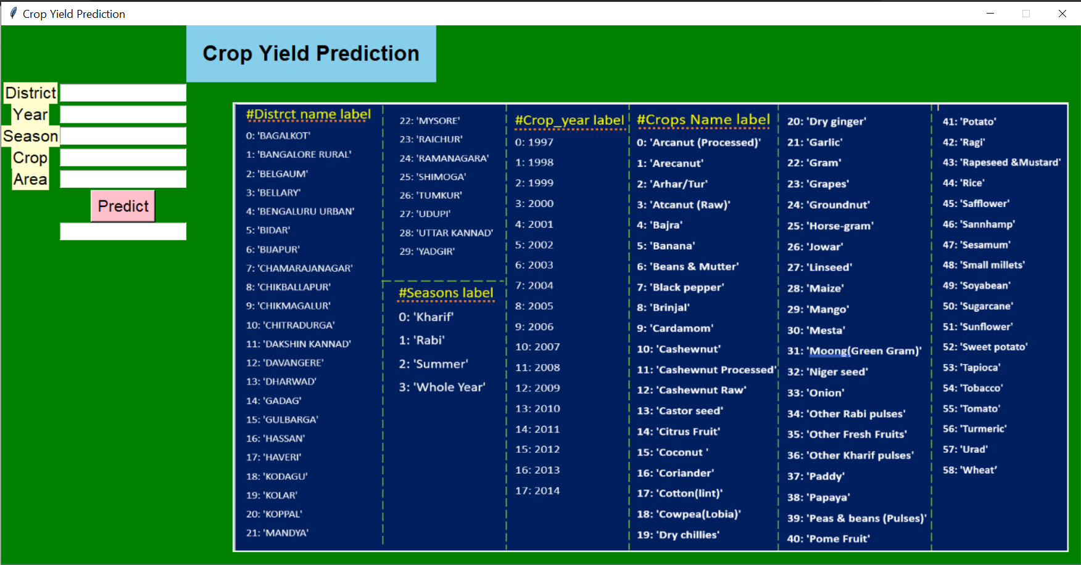
Output page:
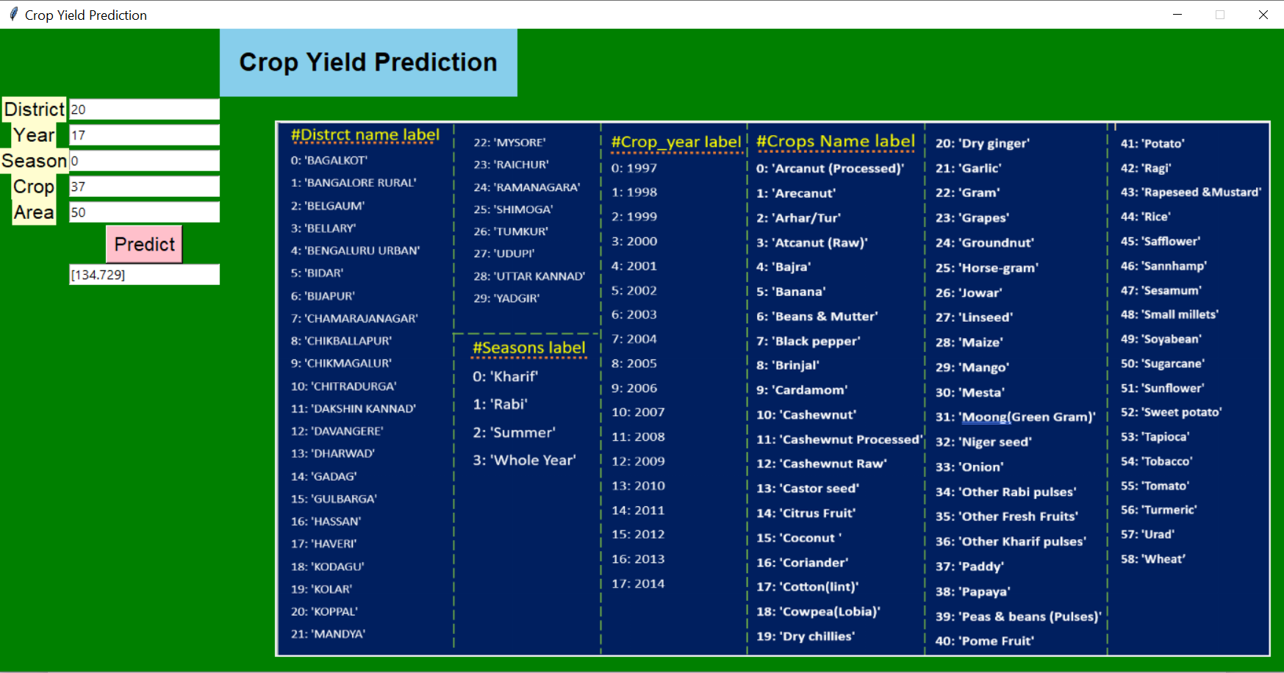

CHAPTER 7: CONCLUSION and FUTURE SCOPE

Developed Model for Crop Yield Prediction is able to predict the yield for crops in Karnataka regions. Based on our analysis by machine learning algorithm called Random Forest regression, this model will be more accurate if the more datasets are available. So as the data point increases our system will become more and more accurate. We try to increase our system accuracy more than the existing system. Since we are displaying the results in the form of tonnes per hectare value with actual and predicted in the graphical user interface it is easy to compare the previous data. This model will help farmers to grow the crop which will give more yield.

REFERENCES
[1] India Meteorological Department Ministry Of Earth Sciences Government Of India:
https://mausam.imd.gov.in/

[2] ICRISAT - Data Management and Analytical Support(DMAS):
http://data.icrisat.org/

[3] Department of Agriculture(KSDA), Government of Karnataka:
https://raitamitra.karnataka.gov.in/info-4/Agriculture+Statistics/en

[4] CRY—an improved crop yield prediction model using bee hive clustering
approach for agricultural data sets
Authors: Ananthara, M. G., Arunkumar, T., & Hemavathy, R.

[5] An intelligent system based on kernel methods for crop yield prediction
Authors: Awan, A. M., & Sap, M. N. M.

[6] Fuzzy Logic based Crop Yield Prediction using Temperature and Rainfall
parameters predicted through ARMA, SARIMA, and ARMAX models
Authors: Bang, S., Bishnoi, R., Chauhan, A. S., Dixit, A. K., & Chawla, I.

[7] Crop Yield Prediction Using Data Analytics and Hybrid Approach

Authors: Bhosale, S. V., Thombare, R. A., Dhemey, P. G., & Chaudhari, A. N.

[8] A study on various data mining techniques for crop yield prediction

Authors: Gandge, Y

[9] Random forest regression algorithm information:
https://www.javatpoint.com/machine-learning-random-forest-algorithm

[10] Crop Yield Prediction using Machine Learning Algorithm; D.Jayanarayan
reddy, Dr M. Rudra Kumar, 2021 5th International Conference on Intelligent
Computing and Control Systems (ICICCS).

[11] Crop Yield Prediction using Machine Learning Techniques;Authors: Ramesh
Medar; Vijay S. Rajpurohit; Shweta Shweta, 2019 IEEE 5th International
Conference for Convergence in Technology

